**Power Flow with Phase Shift**



**Javier Jesús Macossay-Hernández**

**EE443 – Introduction to Power Systems**

**University of Southern California**

**Professor Robert Castro**

**Objective**

In power engineering, a power flow study usually uses simplified notations to focus on various aspects of AC power parameters, such as voltages, voltage angles, real power, and reactive power. Power flow analyzes the power systems in normal steady-state operation. In addition, we are able to modify the direction of real power and reactive power if we change the voltage angle and the voltage, respectively. On Design Case 2 from PowerWorld, the phase shift was used with the concept of changing power flow direction.

**Introduction**

In Figure 1, we can see Design Case 2. This is the case I will use to perform my problem.

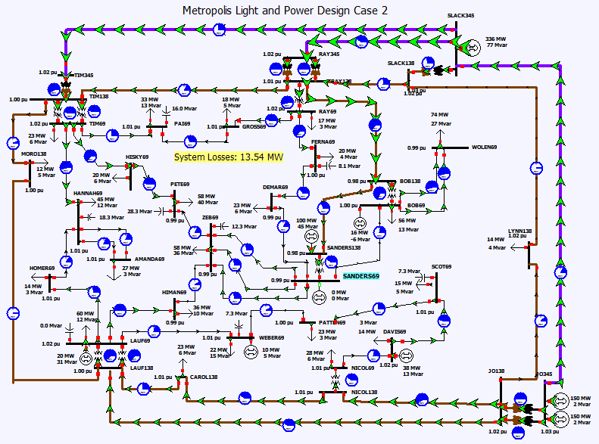

Figure 1: Design Case 2

The steps to complete this problem are the following:

1. Choose a value with two buses on the beginning and end, then transmission lines are needed to connect them.
2. Gather information from PowerWorld (sending, receiving end voltages and angles, transmission line impedance).
3. Do calculations using active power equation, determine power flow and the direction of it.
4. Estimate required angle shift to flow 300 MW power in the opposite direction.
5. Put phase shifting transformer in the PowerWorld.
6. Conclude.

**Methods**

As mentioned before, the first thing to do is to choose an area with two buses and transmission line. The following area is:

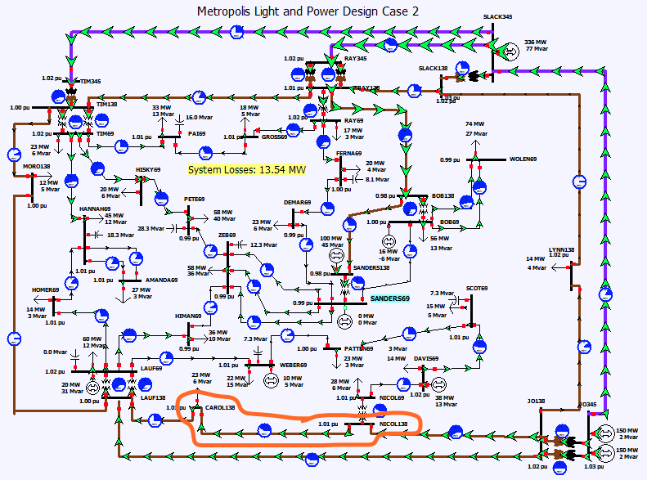

Figure 2: Chosen area on Design Case 2

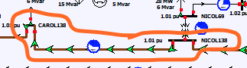

Figure 2: Chosen transmission line

Figure 2: Shows that the chosen area consists of 2 buses, CAROL138 and NICOL138, and a transmission line.

In this problem, the bus NICOL138 will be point A (sending end point) and the bus CAROL138 will be defined as point B (receiving end point). This will be shown in Figure 4 where Vs is NICOL138’s sending end voltage, Vs (angle) is NICOL138’s sending end angle, Vr is CAROL138’s receiving end voltage, Vr (angle) is CAROL138’s receiving end angle, and X is the transmission line impedance.

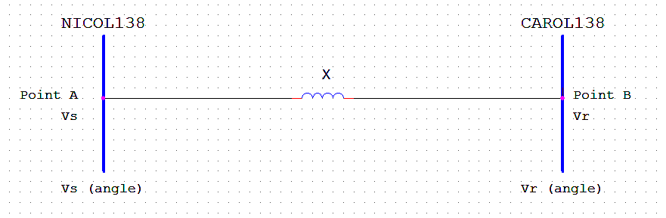

Figure 4: The two buses and transmission line are shown.

**Calculations**

By using PowerWorld, the values shown in the following figures 5 were obtained:

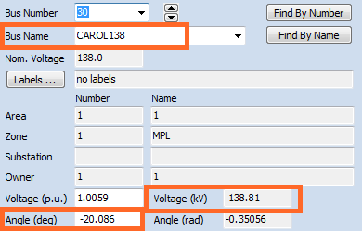

Double click on CAROL138

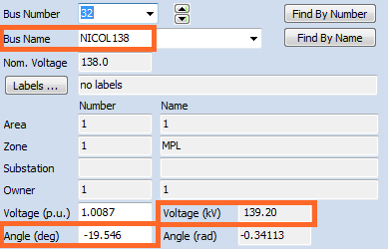

Double click on NICOL138

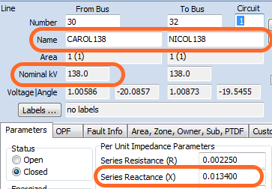

Double click on transmission line

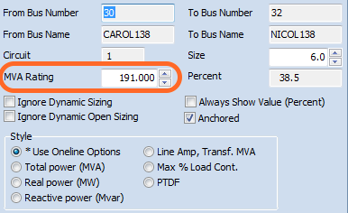

Double click on pie chart

The previous figures show the following values:

Vs = 139.2 kV

Vr = 138.81 kV

Vs (angle) = -19.546°

Vr (angle) = -20.086°

Xpu = j0.0134 pu

Vnominal = 138 kV

Snominal = 191 MVA

Then the power flow was calculated. The power flow can be calculated as follows:

Z = $\frac{V^{2}nominal}{S nominal}$ = $\frac{{\left(138 kV\right)}^{2}}{191 MVA}$ = 99.7 Ω

Xactual = Z*Xpu = (99.7 Ω) (j0.0134 pu) = j1.34Ω

P = $\frac{\left|Vs\right|*\left|Vr\right|}{Xactual}*\sin\left|Vs\left(angle\right)-Vr\left(angle\right)\right|$ = $\frac{\left|138.81 kV\right|*\left|139.2 kV\right|}{j1.34 ohms}*\sin\left|-20.086 degrees-(-19.546 degrees)\right|$ = 135.9 MW

Therefore, the power is 135.9 MW. Then, the power flow direction was calculated as follows: the voltage angle dictates the power flow direction. The power flows from higher voltage angle point (higher angle) to lower voltage angle point (lower angle). Since, -19.546° > -20.086° = Vs (angle) > Vr (angle); therefore, power flows from point A (sending end point) to point B (receiving end point).

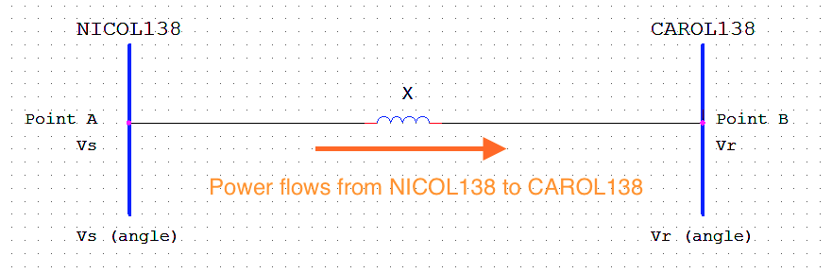

Figure 5: Shows power flow direction

The results were then compared to the ones in PowerWorld. It turned out that in PowerWorld, power also flows from NICOL138 to CAROL138, as shown in Figure 6. The results calculated manually and simulated in PowerWorld are the same.

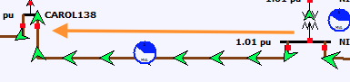

Figure 6: Shows power flow direction in the PowerWorld simulation

Then the required shift angle was calculated in order to make transfer 300 MW power from CAROL138 to NICOL138.

P = $\frac{\left|Vs\right|*\left|Vr\right|}{Xactual}*\sin\left|Vs\left(angle\right)-Vr\left(angle\right)\right|$

300 MW = $\frac{\left|138.81 kV\right|*\left|139.2 kV\right|}{j1.34 ohms}*\sin\left|Vs\left(angle\right)-Vr\left(angle\right)\right|$

$\frac{300 MW*j1.34ohms}{\left|138.81 kV\right|*|139.2 kV|}$ = $\sin\left|Vs\left(angle\right)-Vr\left(angle\right)\right|$ = 0.021

= sin-1(0.021) = 1.19°

Since the sending end angle will not be adjusted, I will correct the receiving end angle.

Vr (angle) = Vs (angle) + 1.19° = -19.546° + 1.19° = -18.356°

Vr (angle)new – Vr (angle)old = -18.356°-(-20.086°) = 1.73°

As a result, the angle will be shift by 1.73°.

Then the phase shifting transformer was introduced in order to change the power flow direction. This can be done in the PowerWorld in the following steps:

1. Switch to Edit mode.
2. Delete existing transmission line between NICOL138 and CAROL138 by clicking on the transmission line and pressing Delete button on the keyboard (choose option Delete Objects Only, it will delete only objects and save the data, so you will not have to insert data again when a new transmission line with a transformer is added).
3. In Ribbon → choose Draw → Network → Transformer → draw a line connecting the CAROL138 and NICOL138 buses → double click → Branch Option window will appear (Figure 7) → Choose Transformer Control window → set up phase shift degrees as 1.73°→ press Ok.

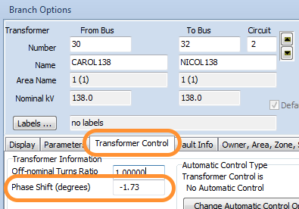

Figure 7: Branch Options

Then the simulation was turned on and it turned out that the power flow changed its direction. The power flows from the CAROL138 bus to the NICOL138 bus, shown in Figure 8.

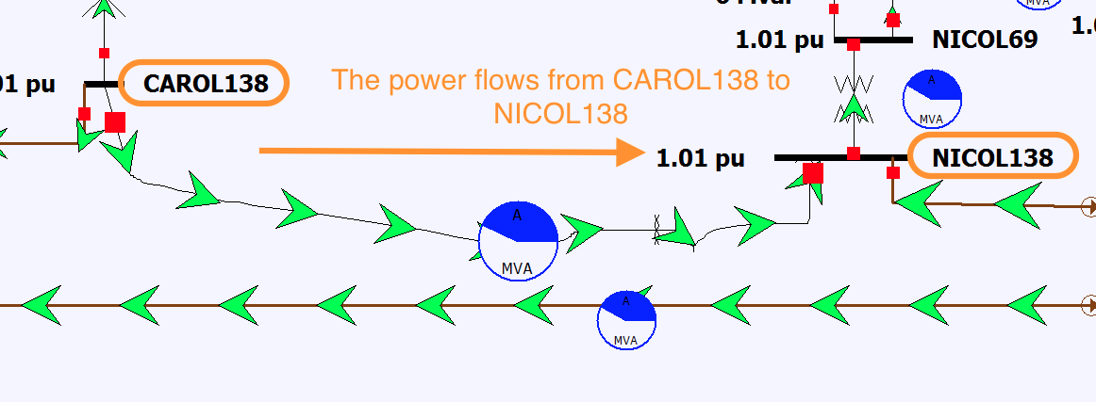

Figure 8: Power flow changed its direction in the PowerWorld simulation

**Results**

The goal was accomplished. First, the power flow and its direction were determined. The manually calculated results were the same as the results from the PowerWorld simulation. Then, the required angle shift to flow 300 MW power in the opposite direction is 1.73°. Finally, the phase shifting transformer was implemented in the PowerWorld simulation.

**Discussion**

In this problem the concept of using the phase shifting transformer was introduced. Information from PowerWorld was gathered (sending, receiving end voltages and angles, transmission line impedance). In addition, manual calculations were performed. As mentioned in the results section, the power flow value and its direction were determined. Then, the results from PowerWorld were compared to the manually calculated results. The information from PowerWorld and the manual calculations yielded to the same results.

Next, the power flow was changed to the opposite direction by adding a phase shifting transformer. The shifting angle was calculated based on formulas we learned in class (power flow equation). 300 MW were assumed to power flow from point B, CAROL 138, to point A, NICOL138. Later, the shifting angle was calculated, which is 1.73° in this problem. This value was used in the phase shifting transformer. Finally, the simulation showed that flow direction changed, as desired, from point B, CAROL138, to point A, NICOL138.